Lambda Expressions
1. Write a Java program using Lambda Expression to print “Hello World!”.
2. Write a Java program using Lambda Expression with single parameter.
3. Write a Java program using Lambda Expression with multiple parameters to add two numbers.
4. Write a Java program using Lambda Expression to calculate the following:
a. Convert Fahrenheit to Celcius
b. Convert Kilometers to Miles.
5. Write a Java program using Lambda Expression with or without return keyword.
6. Write a Java program using Lambda Expression to concatenate two strings.
Problem Statement 1 :Write a Java program using Lambda Expression to print “Hello World!”.
Solution :
package Lambdaexpression;

interface HelloWorld1 {
String sayHello(String name);
}
public class helloworld {
public static void main(String args[]){
HelloWorld1 helloWorld = (String name) -> { return "Hello " + name; };
System.out.println(helloWorld.sayHello("World"));
}
}
Output :
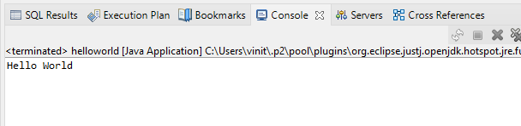

Problem Statement 2 :Write a Java program using Lambda Expression with single parameter.
Solution :
package Lambdaexpression;
interface Say{
public String say(String name);
}
public class singleparameter{
public static void main(String[] args) {
Say s1=(name)->{
return "Hello "+name;
};
System.out.println(s1.say("vinit"));
}
}
Output :
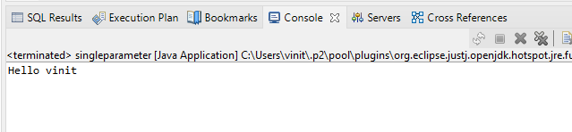

Problem Statement 3 : Write a Java program using Lambda Expression with multiple parameters to add two numbers.
Solution :
package Lambdaexpression;
interface Add{
int add(int a,int b);
}

public class multiplepara{
public static void main(String[] args) {

Add ad1=(a,b)->(a+b);
System.out.println("Sum: " +ad1.add(50,20));

Add ad2=(int a,int b)->(a+b);
System.out.println("Sum: " +ad2.add(700,230));
}
}
Output :
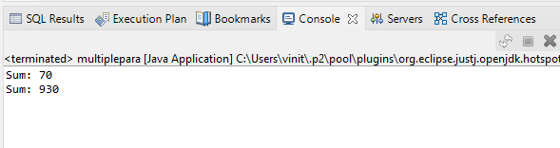

Problem Statement 4 : Write a Java program using Lambda Expression to calculate the following:
- Convert Fahrenheit to Celsius
Solution :
package Lambdaexpression;
interface temp
{
public double convert(double temp);

}
public class farherntoce1 {
public static void main(String[] args) {
temp t1=(double a)->{
return((a-32)* 5/9);
};
System.out.print("Convert fahrenheit to celsius: "+ t1.convert(86));
}

}
Output :
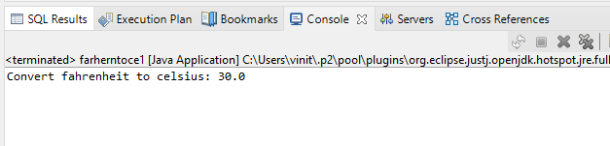

- Convert Kilometers to Miles.
Solution :
package Lambdaexpression;
interface temp1
{
public double convert(double temp);

}
public class kmtomiles {
public static void main(String[] args) {
temp t1=(double a)->{
return(a/1.6);
};
System.out.print("Convert KM to MILES: "+ t1.convert(10)+ " Miles");
}

}
Output :
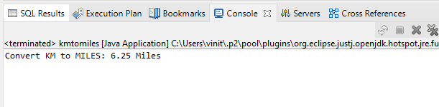
Problem Statement 5 : Write a Java program using Lambda Expression with or without return keyword.
Solution :
package Lambdaexpression;
interface Add2{
int add(int a,int b);
}

public class withwithoutkeywords {
public static void main(String[] args) {
// without return keyword
Add2 ad1=(a,b)->(a+b);
System.out.println("Sum: " +ad1.add(43,23));
// with return keyword
Add2 ad2=(int a,int b)->
{
return (a+b);
};
System.out.println("Sum: " +ad2.add(54,320));
}
}

Output :
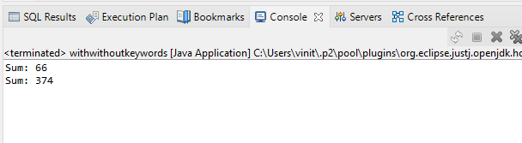

Problem Statement 6 : Write a Java program using Lambda Expression to concatenate two strings.
Solution :
package Lambdaexpression;

interface conc1 {
public String concat(String a,String b);
}
public class concatenate {

public static void main(String[] args) {
conc1 s1 = (String a,String b)->{
return (a+b);
};
System.out.println(s1.concat("Hello"," Vinit"));
}
}
Output :

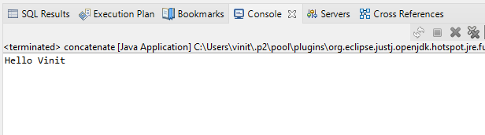
Wildcards in Java
Wildcards are particularly useful when you want to operate on a collection of objects without caring about the exact type of objects in the collection.
The question mark (?) is known as the wildcard in generic programming. It represents an unknown type. The wildcard can be used in a variety of situations such as the type of a parameter, field, or local variable; sometimes as a return type. Unlike arrays, different instantiations of a generic type are not compatible with each other, not even explicitly. This incompatibility may be softened by the wildcard if ? is used as an actual type parameter.
Types of wildcards in Java:
- Upper Bounded Wildcards: These wildcards can be used when you want to relax the restrictions on a variable. For example, say you want to write a method that works on List < integer >, List < double >, and List < number > , you can do this using an upper bounded wildcard.
To declare an upper-bounded wildcard, use the wildcard character (‘?’), followed by the extends keyword, followed by its upper bound.
Syntax: public static void add(List<? extends Number> list)
- Lower Bounded Wildcards: It is expressed using the wildcard character (‘?’), followed by the super keyword, followed by its lower bound: <? super A>.
Syntax: Collectiontype <? super A>

Note: You can specify an upper bound for a wildcard, or you can specify a lower bound, but you cannot specify both.
- Unbounded Wildcard: This wildcard type is specified using the wildcard character (?), for example, List. This is called a list of unknown type. These are useful in the following cases
- When writing a method which can be employed using functionality provided in Object class.
- When the code is using methods in the generic class that don’t depend on the type parameter

Problem Statement 3 : Write a Java Program to demonstrate Wildcards in Java Generics.
Code :
import java.util.*;
public class Wildcardex {
// Upper bounded
private static double sum(List<? extends Number> list) {
double sum = 0.0;
for (Number i : list) {
sum = sum + i.doubleValue();
}
return sum;
}
// Lower Bounded
private static void show(List<? super Integer> list) {
list.forEach((x) -> {
System.out.print(x + " ");
});
}
public static void main(String[] args) {
System.out.println("Upper Bounded : ");
List<Integer> list1 = Arrays.asList(4, 2, 7, 5, 1, 9);
System.out.println("List 1 Sum : " + sum(list1));
List<Double> list2 = Arrays.asList(4.7, 2.4, 7.3, 5.4, 1.5, 9.2);
System.out.println("List 2 Sum : " + sum(list2));
System.out.println("\nLower Bounded : ");
List<Integer> list3 = Arrays.asList(4, 2, 7, 5, 1, 9);
System.out.println("Only Classes With Integer Superclass will be Accepted : ");
show(list3);
}
}
Output :
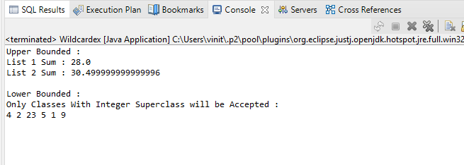

// Java program to demonstrate Upper Bounded Wildcards
// public static void add(List<? extends Number> list)
import java.util.Arrays;
import java.util.List;
class WildcardDemo {
public static void main(String[] args)
{
// Upper Bounded Integer List
List<Integer> list1 = Arrays.asList(4, 5, 6, 7);
// printing the sum of elements in list
System.out.println("Total sum is:" + sum(list1));
// Double list
List<Double> list2 = Arrays.asList(4.1, 5.1, 6.1);

// printing the sum of elements in list
System.out.print("Total sum is:" + sum(list2));
}
private static double sum(List<? extends Number> list)
{
double sum = 0.0;
for (Number i : list) {
sum += i.doubleValue();
}
return sum;
}
}
Output
Total sum is:22.0
Total sum is:15.299999999999999
Explanation:
In the above program, list1 and list2 are objects of the List class. list1 is a collection of Integer and list2 is a collection of Double. Both of them are being passed to method sum which has a wildcard that extends Number. This means that list being passed can be of any field or subclass of that field. Here, Integer and Double are subclasses of class Number.

Lower Bounded Wildcards:
It is expressed using the wildcard character (‘?’), followed by the super keyword, followed by its lower bound: <? super A>.
Syntax: Collectiontype <? super A>
// Java program to demonstrate Lower Bounded Wildcards
import java.util.Arrays;
import java.util.List;
class WildcardDemo {
public static void main(String[] args)
{
// Lower Bounded Integer List
List<Integer> list1 = Arrays.asList(4, 5, 6, 7);

// Integer list object is being passed
printOnlyIntegerClassorSuperClass(list1);
// Number list
List<Number> list2 = Arrays.asList(4, 5, 6, 7);

// Integer list object is being passed
printOnlyIntegerClassorSuperClass(list2);
}
public static void printOnlyIntegerClassorSuperClass(
List<? super Integer> list)
{
System.out.println(list);
}
}
Output
[4, 5, 6, 7]
[4, 5, 6, 7]
Explanation:
Here arguments can be Integer or superclass of Integer(which is Number). The method printOnlyIntegerClassorSuperClass will only take Integer or its superclass objects. However, if we pass a list of types Double then we will get a compilation error. It is because only the Integer field or its superclass can be passed. Double is not the superclass of Integer.

3. Unbounded Wildcard:
This wildcard type is specified using the wildcard character (?), for example, List. This is called a list of unknown types. These are useful in the following cases –
- When writing a method that can be employed using functionality provided in Object class.
- When the code is using methods in the generic class that doesn’t depend on the type parameter
// Java program to demonstrate Unbounded wildcard
import java.util.Arrays;
import java.util.List;
class unboundedwildcardemo {
public static void main(String[] args)
{ // Integer List
List<Integer> list1 = Arrays.asList(1, 2, 3);
// Double list
List<Double> list2 = Arrays.asList(1.1, 2.2, 3.3);
printlist(list1);
printlist(list2);
}
private static void printlist(List<?> list)
{
System.out.println(list);
}
}
Output
[1, 2, 3]
[1.1, 2.2, 3.3]

